# Recipes

You need to add 17 things to this document. (Make sure to number them just as I did in the example.) It may be helpful to copy and paste this list and then fill it in as you go along. All image names must start with your location, e.g yellowstone_sunset.jpg unless you are using a link from the internet.

[Link to Recipe Files](https://drive.google.com/drive/folders/1F83jwW9ih3Bk01g87RWiQ2CT65Ct74_p)

## Homemade Mac & Cheese

1. **Origin**: Northern Europe
2. **Source**: <https://www.delish.com/cooking/recipe-ideas/a44763401/mac-and-cheese-recipe/>
3. **Category**: Main Dish.

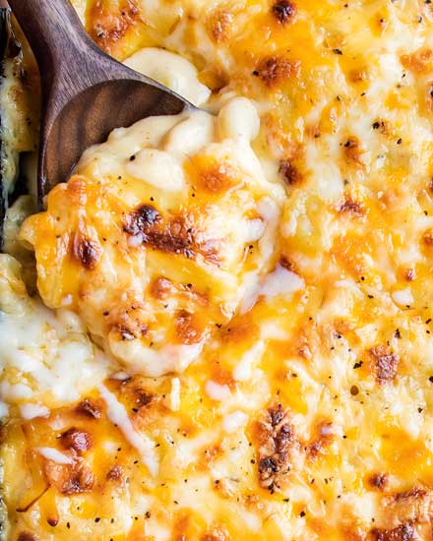

1. mac&cheese.jpg
2. Macaroni and cheese, commonly known as mac & cheese, is a comfort food staple that has captured the hearts of people all over the world. Originating from Europe and popularized in the United States, this dish consists of elbow macaroni pasta smothered in a creamy cheese sauce. The simplicity of its ingredients—pasta, cheese, and often a touch of butter or milk—belies a rich, complex flavor that has made it a favorite for both quick weeknight dinners and festive holiday gatherings.
3. **Recipe Ingredients – Just write Recipe Ingredients**
   1. Macaroni
   2. Butter and flour
   3. Milk
   4. Cheese
   5. Seasonings
   6. Bread crumbs
4. **Recipe Steps – Just write Recipe Steps**
   1. Preheat oven to 375°. Grease a 13"x9" baking dish with butter. In a large pot of boiling salted water, cook macaroni, stirring occasionally, until al dente, 5 to 6 minutes. Drain.
   2. In a large saucepan over medium heat, melt 1 stick butter. Sprinkle flour over and cook, stirring, until slightly golden, 2 to 3 minutes. Pour in milk and whisk until combined. Add mustard powder; season with salt and pepper. Bring to a simmer over medium-high heat and cook, stirring, until sauce starts to thicken, about 2 minutes.
   3. Remove pan from heat and whisk in cheddar, Gruyère, and 1 cup Parmesan until melted and smooth. Stir in macaroni and transfer to the prepared dish.
   4. In a small bowl, combine panko, oil, and remaining 1/2 cup Parmesan. Sprinkle over macaroni; season with more pepper.
   5. ​​Bake mac and cheese until bubbly and golden, 25 to 30 minutes. Let cool for 10 minutes.
5. **Additional Food images**

For the next three pictures, you can just put the names of the files, you don't have to include the files in this drive, but you do need to add them to the proper Google Drive.

1. mac&cheese2.jpg
2. Instant cook mac and cheese, allows you to eat within five minutes.
3. mac&cheese3.jpg
4. Well-cooked mac and cheese with a full load of cheese.
5. mac&cheese4.jpg
6. Mac and cheese cooked in a nice cookware.
7. Linghao Shi